**Lutong Bahay: An Ingredient Inventory and Recipe Smartphone Application**

A Project Proposal

Presented to the College of Engineering

University of San Carlos

Cebu, City Philippines

In Partial Fulfillment of the Requirements for the Degree

**Bachelor of Science in Computer Engineering**

By

Dr. Marlowe Edgar C. Burce, PhD

Engr. Arnold V. Roso

Chariz Stephanny O. Abaño

Apple Regine Y. Arriesgado

Christian Emmanuel B. Boyboy

Luke Nigel J. Laylo

Christian B. Roullo



October 2013

© 2014 Dr. Marlowe C. Burce, Engr. Arnold Roso, Chariz Stephanny O. Abaño, Apple Regine Y. Arriesgado, Christian Emmanuel B. Boyboy, Luke Nigel J. Laylo, Christian B. Roullo

All Rights Reserved 2013

**Lutong Bahay: An Ingredient Inventory and Recipe Smartphone Application**

by

Dr. Marlowe Edgar C. Burce, PhD, Engr. Arnold V. Roso, Chariz Stephanny O. Abaño, Apple Regine Y. Arriesgado, Christian Emmanuel Y. Boyboy, Luke Nigel J. Laylo, Christian B. Roullo

has been reviewed and approved.

SIGNED BY:

DR. MARLOWE EDGAR C. BURCE, PhD

Adviser, Project Design

ENGR. ARNOLD V. ROSO

Co-Adviser, Project Design

University of San Carlos



DEPARTMENT OF COMPUTER ENGINEERING

Talamban Campus, Cebu City

# Project Approval Sheet

|  |
| --- |
| **Title of Project : Lutong Bahay: An Ingredient Inventory and Recipe Smartphone Application** |
| **Adviser**  **: Dr. Marlowe Edgar C. Burce, PhD** |
| **Co-Adviser : Engr. Arnold V. Roso** |
|  |
| **Proponents :** |

|  |  |  |  |
| --- | --- | --- | --- |
| **Name** | **Course & Year** | **ID Number** | **Remarks** |
| Abaño, Chariz Stephanny O. | BSCOMPE - 5 | 09304310 | _____________ |
| Arriesgado, Apple Regine Y. | BSCOMPE – 5 | 09304149 | **_____________** |
| Boyboy, Christian Emmanuel B. | BSCOMPE – 5 | 09304663 | **_____________** |
| Laylo, Luke Nigel J. | BSCOMPE – 5 | 09304312 | **_____________** |
| Roullo, Christian B. | BSCOMPE – 5 | 09305429 | **_____________** |

### Date of Final Presentation

**August 31, 2013**

**PANEL COMMITTEE**

|  |  |  |
| --- | --- | --- |
| **Engr. Christopher James Labrador**  Committee Chair | | |
| **Engr. Christian Maderazo**  Committee Member |  | **Engr. Christine Mae Gohetia**  Committee Member |

**ACCEPTED BY**

**ENGR. VAN B. PATILUNA**

Chairman, Department of Computer Engineering

## ACKNOWLEDGEMENT

The proponents would like to take the opportunity to extend their gratitude to the following people who have helped and shared their knowledge and support in the development of this project.

To **Dr. Marlowe Burce** and **Engr. Arnold Roso,** for guiding us throughout the development of this project;

To our parents, **Mr. and Mrs. Abaño, Mr. and Mrs. Arriesgado, Mr. and Mrs. Boyboy, Mr. and Mrs. Laylo, and Mr. and Mrs. Roullo,** for always giving moral and financial support. For continuously giving their love and care despite our hardships;

To **friends** and **classmates**, for constantly helping and giving moral support;

And lastly, to our **Almighty God the Father,** for giving us the strength to overcome the hardships that we have encountered.

# TABLE OF CONTENTS

ACKNOWLEDGEMENT v

TABLE OF CONTENTS vi

LIST OF TABLES xi

LIST OF FIGURES xii

LIST OF EQUATIONS xiii

CHAPTER 1 1

PROBLEM SETTING AND BACKGROUND 1

1.1. Introduction 1

1.2. The Problem 2

1.3. Goals and Objectives 2

1.4. Significance of the Study 3

1.5. Scope and Limitation 3

1.6. Theoretical Background 4

1.6.1. Hypertext Markup Language 5 (HTML 5) 5

1.6.2. JQuery 6

1.6.3. Cascading Style Sheet (CSS) 6

1.6.4. JQuery Mobile 6

1.6.5. PhoneGap Framework 7

1.6.7. Eclipse 7

1.6.8. Weighted Averaging Method 7

1.6.9. Heuristic Evaluation 8

1.6.10 Quantitative Data Statistics 8

1.6.11 Qualitative Data Statistics 9

1.7. Definition of Terms 10

CHAPTER 2 11

REVIEW OF RELATED LITERATURE AND STUDIES 11

CHAPTER 3 18

METHODOLOGY 18

3.1. Project Management 18

3.1.1. Project Assumptions 18

3.1.2. Project Constraints 18

3.1.3. Risk Assessment and Analysis 19

3.1.4. Team Structure 20

3.1.5. Project Resources 21

3.1.6. Work Breakdown Structure 23

3.1.7. Network Diagram and Critical Path 23

3.1.8. Project Schedule 25

3.1.9. Project Budget 28

3.2. Proposed Software Design 29

3.2.1. Hardware Requirements 29

3.2.2. Software Requirements 29

3.2.3. Network Requirements 29

3.2.4. System of Software Limitations 29

3.2.5. System Process Model 30

3.2.6. Software Architecture 30

3.2.7. Software Analysis and Design 31

3.3. Software Testing 41

3.3.1. Unit Testing 41

3.3.2. Integration Testing 44

3.3.4. Beta Testing 48

3.3.5. User Acceptance Testing 48

3.3.6. Usability Testing 49

3.4. Deployment 49

3.5. Data Gathering and Interpretations 49

3.5.1. Gathering of Data 50

3.5.2. Treatment of Data 50

HYPOTHESIS 53

BIBLIOGRAPHY 54

APPENDIX A 56

APPENDIX B 59

APPENDIX C 65

## LIST OF TABLES

Table 3. 1 Risk with high severity 19

Table 3.2 Risk with medium severity 20

Table 3.3 Risk with low severity 20

Table 3.4 Task List 24

Table 3.5 Budget Schedule 26

Table 3.6 Actual Cost 28

Table 3. 7 Test Cases for Administrator Module 43

Table 3.8 Test Cases for User Module 44

Table 3.9 Test Cases for Integration Testing 45

## LIST OF FIGURES

Figure 3.1 Team Structure 21

Figure 3.2 Work Breakdown Structure 23

Figure 3.3 Program Evaluation and Review Technique (PERT) 1 Format 25

Figure 3.4 Network Diagram and Critical Path 25

Figure 3.5 Gantt Chart 27

Figure 3.6 Waterfall Development Life Cycle Model 30

Figure 3.7 Software Architecture 31

Figure 3.8 Use Case Diagram 32

Figure 3.9 Main Flowchart 33

Figure 3.10 Ingredient Inventory Flowchart 35

Figure 3.12 About Page Flowchart 38

Figure 3.11 Recipe Page Flowchart 38

Figure 3.13 Entity Relationship Diagram 40

Figure 3.14 Method 1 41

Figure 3.15 Method 2 42

## LIST OF EQUATIONS

Equation 3.1 Range 48

# CHAPTER 1

# PROBLEM SETTING AND BACKGROUND

## Introduction

A common problem for most household cooks is that they may have the ingredients in their kitchen but they do not know what recipes to cook. You may look through some cookbooks for recipes but on the other hand you may not have some of the ingredients needed. There are even some electronic copies of recipes today but still it doesn’t help out much in deciding what you can cook with your ingredients.

With the technology today, there are a lot of open source electronic recipe programs around the internet available for download like Betty Crocker, Cookbook, Supercook, and many more. But these programs have only a little advantage when compared to a book. Other programs may also require internet connection in order to run the application. In other words, there are not so many available programs that will be both helpful in monitoring ingredients and suggest recipes based from the ingredients.

To take advantage of the technology today, the proponents have decided to create a smartphone application that will suggest recipes that are ready to cook based on the ingredients it contains that matches up in the ingredients inventory. This inventory is where the user must enter and update the available ingredients in the kitchen for use. With the use of the inventory, the user can monitor the available ingredients for cooking. The application will be called Lutong Bahay.

## The Problem

There are mobile cookbooks today that give you recipes. However, there are times that you don't know what to cook based on the recipe ingredients available in the kitchen. It would take time for them to think of what to cook. Specifically, this project intends to address the following problems:

* What to cook with the ingredients available in the kitchen.
* How to monitor the availability of ingredients in the kitchen.

## Goals and Objectives

This study aims to develop a smartphone application that can match ingredients from the ingredients inventory and suggest recipes. Specifically, this aims to:

* To create a function that will suggest recipes based on the available ingredients in the ingredients inventory.
* To develop an application that would run on an android smartphone with OS version 2.2 or higher.
* To create an ingredient inventory system that will be part in Lutong Bahay.

## Significance of the Study

Lutong Bahay would be beneficial to the household members. This will help them monitor the ingredients available in the kitchen and decide on what recipes to cook based on their available ingredients.

## Scope and Limitation

Lutong Bahay has the capability of suggesting recipes based on the ingredients present in the ingredients inventory. This will be implemented using PhoneGap that supports Android platform and web standards (HTML, CSS and JAVASCRIPT). During the execution of Lutong Bahay, there will be no internet connection required.

Lutong Bahay is specifically intended for one user per household only. The user will have to enter the available ingredients from the kitchen into the ingredients inventory in order for the application to suggest recipes to choose from. Also the user will have to manually update the inventory whenever new ingredients are bought. The unit of measurement is fixed for certain ingredients. The user may also update the application through syncing it to the developers’ webpage. The user may view the suggested recipes by category.

Because there is only little amount of memory space available in a mobile phone, there might be only a maximum of 150 recipes. The ingredients and recipes will be stored in SQLite which will be the database of the application.

## Theoretical Background

A cookbook is a book that contains a collection of recipes from different food categories. Each recipe contains specific recipe ingredients quantity and its corresponding procedure. Cookbooks have been made into web application for easy access and now into mobile application. Smartphones are mobile phones that are built on a mobile operating system such as Android. Mobile applications are created and executed on smartphones.

These are the collection of theories and concepts that will later be used in the development of Lutong Bahay. These theories and concepts will help further understand how the system will be implemented.

The Lutong Bahay will be developed following the Waterfall Software Development Life Cycle methodology. The Waterfall process model enables a sequential development of the system through its development phases.

For the Frontend side of the Lutong Bahay, HTML5, CSS and JQuery will be used. HTML5 is for structuring and presenting in the smartphone application. CSS is for the design of the user interface as it gives full control of the style and layout of each page. JQuery Mobile is for more interactive graphical user interface (GUI) system on a mobile device platform. For the database, SQLite will be used for storing and retrieval of data and this will be embedded in the application. Upon compiling the application, Eclipse IDE will be used.

In order for the Lutong Bahay to be executed in Smartphones, PhoneGap framework will be used in building the application using HTML5, CSS, and JavaScript. Lutong Bahay will be deployed upon development completion. Qualitative and Quantitative research style will be used to assess the overall performance of the system. In data gathering a heuristic evaluation is used, weighted averaging method is used in evaluating the average outcome in the data that are gathered.

### 1.6.1. Hypertext Markup Language 5 (HTML 5)

The standardized markup language for developing web pages has been the Hypertext Markup Language (HTML). HTML5 is used for structuring and presenting content for the World Wide Web and core technology of the internet. It will be used for developing the layout of the proposed system.

### 1.6.2. JQuery

JQuery is a new kind of JavaScript Library. JQuery is a fast and concise JavaScript Library that simplifies HMTL document traversing, event handling, animating, and Ajax interactions for rapid web development. JQuery is designed to change the way that you write JavaScript.

### 1.6.3. Cascading Style Sheet (CSS)

CSS is a web-based mark-up language used to describe the style and layout of a website to the browser. CSS 3 is the latest standard for CSS with additional capabilities. CSS 3 is the presentation layer of a web page since it provides impressive visual effects, better user interface and cleaner pages that load faster than before.

### 1.6.4. JQuery Mobile

JQuery Mobile is unified HTML 5-based user interface system for a mobile device platform built on the JQuery and JQuery UI foundation. It has a flexible, and easily themeable design. JQuery mobile framework is a cross-platfrom with HTML 5, it allows you to design a single highly-branded application that will work in all popular smartphone, tablet and desktop.

### 1.6.5. PhoneGap Framework

PhoneGap is a free and open source framework that allows you to create application using standardized web APIs for the platforms, it uses HTML, CSS and JavaScript. It can support the following features: Accelerometer, camera, compass, contacts, file, geolocation, media, network, notification (alert: sound, vibration), and storage.

### 1.6.7. Eclipse

Eclipse is a multi-language Integrated Development Environment (IDE). It has a plug-in called Android Development Tools (ADT) which is designed to give powerful, integrated environment in which to build Android applications. ADT extends the capabilities of Eclipse to let the developer to quickly set up new Android projects, create and application UI, add packages based on the Android Framework API, debug applications using Android SDK tools, and export android application package (apk) files to distribute the applications**.**

### 1.6.8. Weighted Averaging Method

In business the weighted average method is used to assign the average cost of a product to a product. When using the weighted average method, you divide the cost of goods available for sale by the number of units available for sale which yields the weighted-average cost per unit.

### 1.6.9. Heuristic Evaluation (incorrect indentation/paragraphing)

A heuristic evaluation is a method used for identifying the usability problems in the user interface (UI) design. It involves evaluators examining the interface and judging its compliance with recognized usability principles. The heuristic evaluation is conducted in the context of the use cases, to provide feedback to the developers on the extent to which the interface is likely to be compatible with the intended users’ needs and preferences. The most used usability heuristics which was developed by Jakob Nielsen for user interface design were: visibility of system status, match between system and real world, user control and freedom, consistency and standards, error prevention, recognition rather than recall, flexibility and efficiency of use, aesthetic and minimalist design, help users recognize, diagnose, and recover from errors, and help and documentation.

### 1.6.10 Quantitative Data Statistics

Quantitative data are measures of values which are expressed as numbers. It is used to get a picture of a population. Graphs and tables are used in showing the frequency of a data item in quantitative data. Statistics that describe or summarizes data are produced for quantitative data. All descriptive statistics can be calculated using quantitative data. It will be used in gathering the data in user acceptance testing.

### 1.6.11 Qualitative Data Statistics

Qualitative data measures of types and may be represented by a name, symbol or number code, and in categories. It approximates or characterizes but does not measure the attributes, characteristics, properties, etc. of a thing or phenomenon. It will be used in gathering the data in user acceptance testing.

## Definition of Terms

* **Lutong** **Bahay** - is the application name??? too short definition.
* **Client** - anyone who is able to use Lutong bahay; anyone in the household. (Ambiguous!!!)
* **Category** - is a part in searching a recipe according to difficulty, consumers and methods.
* **Consumers** - is where the client chooses who will be benefit for the chosen recipe.
* **Methods** - are the style (what style???) of cooking that the recipe is using.
* **Difficulty** - there would be 2 levels the basic recipe and the advance recipe.
* **Sync** - it updates new recipes from the internet to your smart phone.
* **Ingredients** **Inventory** - is the current ingredients in your household.
* **Logs** - a record of recipes that the clients have chosen.

# CHAPTER 2

# REVIEW OF RELATED LITERATURE AND STUDIES

**2.1. Home Library**

Farooqui (2013) developed an application that helps you maintain your library at your home like books, cd’s and dvd’s. This application is implemented through the use of a smartphone that runs on an IOS platform. The application can store your books and cd’s by scanning the barcode of the item. It can keep track of your books and cd’s you’ve lent Mike Lajeunesse ( ) to people. It keeps track of all your books and cd’s and stores them in an online database.

In relation to our study, both projects have the same implementation by the use of Smartphone. However, in our study we prefer to use a Smartphone that runs in an Android operating system. The projects methodology also aided the proponents in various ideas on the process of tracking and storage of resources.

**2.2. Inventory Matching Software**

A study was conducted by the company Medical Materials with the leadership of regarding the medical inventory matching system which is designed for the materials used in hospitals for their products.

“They made a system for the inventory of the hospital that allows medical materials to match the products the hospital is using. This program provides the list that they will be using through email with the matching items. It would also send a purchase order that will be sent through email.”

In relation to our study, our proposed project will also be using an inventory that will match to the possible recipe. The application will provide the list of possible recipe with the given number of ingredients presented in the inventory. However, we have different implementations; the medical inventory software is implemented through the web while our application is implemented through a Smartphone.

**2.3. CookBook: An Android Mobile Platform Application**

  Popovici’s, et. al. (2009) project presents an application named CookBook designed for Android mobile platform. It mainly focuses on: search recipes by ingredients, shopping list for ingredients, and exchange of recipes. The user of the application has the freedom to choose between these features. Searching recipes by ingredients allows the user to search recipes based on the ingredients it contains. The shopping list manager generates a shopping list of ingredients for the recipe that the user decided to cook. Exchange of recipes is possible via e-mail or text messages.

            The proponents will use CookBook as reference for searching recipes.  The same concept will be applied in the proponents’ study which Lutong Bahay will suggest a list of recipes based on the available ingredients in the kitchen. However, there will be an improvement in Lutong Bahay. Compared to CookBook, it doesn’t have an inventory system where the ingredients will be monitored.

**2.4. Android as a Platform for Database Application Development – Case: Winha Mobile**

 Muli’s (2013) study focuses on the integration of database in an Android Operating System, specifically on mobile devices and discussed how it is implemented. Android Operating System & Database Package were also discussed, as well as its application fundamentals, components and resources. At the end of the study an output was produced called Winha Mobile where it meets the goal of this project that is to be able to insert, update, view, and delete records.

            Through this study, the proponents were given the idea of how to implement the use of database for an android phone. The proponents will use this some methods used in this study in accessing the database.

**2.5. Building Android Apps with HTML, CSS, and JavaScript**

 Stark’s (2010) book simply serves as a guide for the reader on how to form an Android application using HTML, CSS, and JavaScript from scratch. PhoneGap was also discussed about how it is implemented for the development of an application.

            This book will be helpful for the proponents’ project during the development of Lutong Bahay with HTML, CSS, and JavaScript. This book will be the basis of the proponents in creating the user-interface of Lutong Bahay.

**2.6. Case Study: Recipe Search MicroApp**

Levitt (2009) created a website is about suggestion of recipes that focuses in searching for recipe ingredients and suggests recipe articles via Content API where it identifies ingredients on articles, indexes data, and optimizes results for the user using some tagging and refinement features of the Content API. Search by ingredients allows the user to identify on what recipe ingredients the user wants and what recipe ingredients the user dont wanna have. The user is also allowed to search by recipe names where recipe names came from different recipe cooking articles in the internet.

This study almost have similar concept to the proponents study, the search for ingredients and suggest of recipe. The Lutong Bahay difference is that it would suggest a list of recipes base from the ingredients inputted by the user. The proponents create an inventory system for recipe ingredients where recipes are suggested and will be embedded in the mobile application that executes on a Android Smartphone.

**2.7. Mobile Application Development: Web vs. Native**

Charland and Leroux (2011) discussed that most native platforms have wonderful abstractions for common user-interface controls. Web code uses HTML and CSS and javascript, while native code, it is painted pixels on screens through the propriety APIs and abstractions for common user-interface elements and controls. The article also discusses about using of PhoneGap where it is an open source framework the can provide the developers an environment where they can create applications in HTML, CSS and JavaScript and still call native device features and sensors via a common JS API, the PhoneGap framework contains the native-code pieces to interact with the underlying operating system and pass information back to the JavaScript application running in the Webview container.

In relation to the proponents’ development of the smartphone application, web codes such as HTML, JavaScript and CSS will be used to develop the smartphone application which can be achieved by using the PhoneGap framework.

**2.8. The Betty Crocker Mobile Cookbook**

The Betty Crocker Mobile Cookbook an application that allows user to search recipes by entering the ingredients the user has. A database was used for the storage of the recipes. Also, the recipes come with photos, a step by step instructions and nutritional information.

Both projects differ on implementation and application. However both projects have the same function which is to suggest recipes to the user based on what they have. Betty Crocker’s cookbook lets you input what recipe ingredient you have and what type of food you want to make, in contrast to our project, our project will have a database which the user will store the recipe ingredients and based on the recipe ingredients the system will automatically suggest recipes to the user.

**2.9. Schema Matching and Database Integration**

Karasneh et al. (2009) talked about database matching and integration in this study. They proposed a framework and an approach to integrate several database schemas through two main processes, these are, matching process and integration process. A general framework that supports the integration of local schemas into a global one is needed in many database applications. This research proposed an approach, to match the schemas. It performed schema comparison.

This study serves as a reference to the proponents in constructing the database. The proponents might use the approach in matching and integration introduced in the study in implementing Lutong Bahay.

**2.10. Intelligent food planning: Personalized recipe recommendation**

Freyne and Berkovsky (2010) looked into the design of a recipe recommender system. First, they focused on data capture and food-recipe relationship then present a study of the suitability of different recommender algorithms. Freyne and Berkosky (2010) showed that the solicitation of recipe ratings, which are transferred to food ratings through a food’s inclusion in recipe, is an accurate and effective method of food capturing preferences. The strategies used in data gathering are ratings on individual food item and recipe ratings on recipe. They concluded that reasonable accuracy can be achieved with the use of content-based strategies and relating recipes and food items.

The study will make use of ratings in recommending recipes to the user. In relation to the proponents study, the proponents will create an application that will make use of the ingredients available in the ingredients inventory. This study will be helpful to the proponents since it presents algorithms in data gathering and recommending recipes.

# CHAPTER 3

# METHODOLOGY

## 3.1. Project Management

### 3.1.1. Project Assumptions

During the implementation of the project, the proponents assume:

1. That each proponent has basic knowledge of the following:
   1. HTML
   2. CSS
   3. JavaScript
2. That the application will be fully functional during the execution.

### 3.1.2. Project Constraints

The proponents allocated some attention to the constraints which could delay the development of the study:

1. Differences in opinion in which might cause a delay in the development of the project.
2. Unfamiliarity with development technology.
3. Lack of resources.
4. No proper time management.

### 3.1.3. Risk Assessment and Analysis

These are some risks that might be encountered during the implementation of Lutong Bahay. The tables below shows the risk identified by the researchers as listed according to severity:

Table 3. 1 Risk with high severity

|  |  |  |  |
| --- | --- | --- | --- |
| **Risk** | **Cause** | **Contingency Plan** | **Probability** |
| **Risks With High Severity** | | | |
| Accidents | Unexpected events | First aid or go to hospital | High |
| Data loss | Unable to secure back up for files | Secure back up constantly | High |
| Bugs found after developing the system | Coding problems, unable to test properly the system | Test the system properly | High |
| Health Problems | Stress, improper diet, lack of sleep | Take vitamins, find time to sleep, time management | High |
| Distractions | Lack of focus | Proper discipline in making the project | High |

Table 3.2 Risk with medium severity

|  |  |  |  |  |
| --- | --- | --- | --- | --- |
| **Risk** | **Cause** | | **Contingency Plan** | **Probability** |
| **Risks With Medium Severity** | | | | |
| Power Loss | | Brown outs, Calamities | Wait for the electricity to come back | Medium |
| Failure to deploy on time | | Unable to follow schedule | Be aware of due dates and follow the schedules given | Medium |
| No teamwork and cooperation between members | | Character or attitude problems, stress, | Stick to the plan, continue to work, adjust to the attitudes | Medium |
| Changing of preferences during developmental stage | | Unable to comply the software properly and changing of scope of the project | Stick to the scope of the system | Medium |

Table 3.3 Risk with low severity

|  |  |  |  |  |  |
| --- | --- | --- | --- | --- | --- |
| **Risk** | **Cause** | | **Contingency Plan** | | **Probability** |
| **Risks With Low Severity** | | | | | |
| Loss of member | | stop schooling | Continue to work and share the work load to other members | Low | |
| Attitude problems and conflict of interests | | Character or attitude problems, stress | Stick to the plan and continue to work | Medium | |

### 3.1.4. Team Structure

The team structure presented in Figure 3.1 represents the duty and responsibilities of each proponent in the implementation of the project.

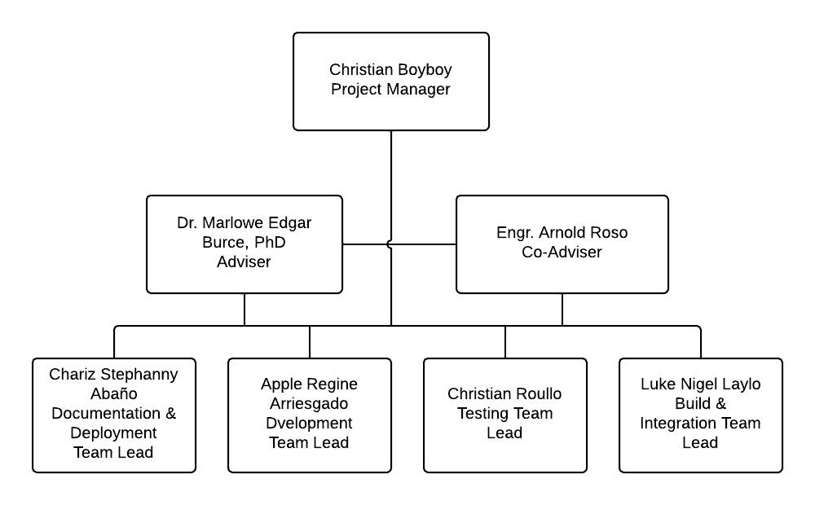

Figure 3.1 Team Structure

### 3.1.5. Project Resources

The following resources have been identified by the proponents in the implementation of the project. Moreover, these resources are divided into: Human Resources, Software Resources and Hardware Resources. The following shows the breakdown of the project resources.

**Human Resources**

1. Proponents and developers
   1. Chariz Stephanny Abaño
   2. Apple Regine Arriesgado
   3. Christian Emmanuel Boyboy
   4. Luke Nigel Laylo
   5. Christian Roullo
2. Adviser
3. Dr. Marlowe Edgar Burce, PhD
4. Co-Adviser
5. Engr. Arnold Roso
6. Client Tester
7. Household Members

**Hardware Resources**

1. Computers
2. Smartphones
3. Printers

**Software Resources**

1. PhoneGap
2. Microsoft Office
3. Windows 7
4. SqlLite Database
5. Google Chrome and Mozilla Firefox (Latest versions)
6. Jquery Mobile
7. Free Website Hosting

### 3.1.6. Work Breakdown Structure

Figure 3.2 is the work breakdown structure of the system. The work is divided in to two parts, the *System Initialization* and *System Implementation.*

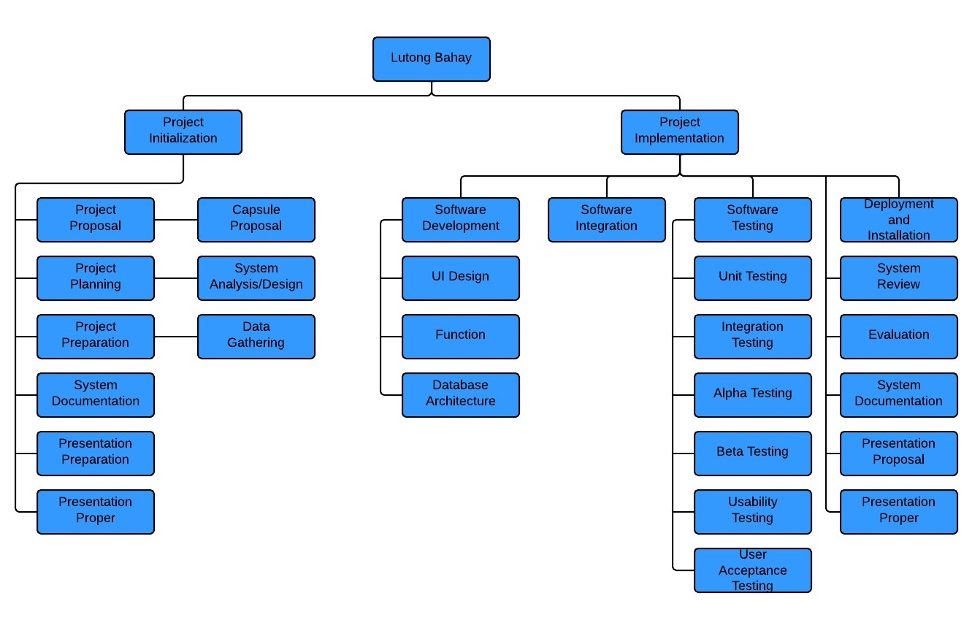

Figure 3.2 Work Breakdown Structure

### 3.1.7. Network Diagram and Critical Path

Table 3.4 Task List

|  |  |  |  |
| --- | --- | --- | --- |
| Task | Task Name | Predecessor | Duration |
| A | Project Proposal | - | 12 days |
| B | Project Planning | A | 25 days |
| C | Project Preparation | B | 15 days |
| D | System Documentation | C, B | 13 days |
| E | Proposal Presentation Preparation | D,C | 5 days |
| F | Proposal Presentation Proper | E | 1 day |
| G | Software Development | F | 55 days |
| H | System Integration | G | 10 days |
| I | System Testing | H | 10 days |
| J | Deployment and Installation | I | 7 days |
| K | Evaluation | J | 30 days |
| L | System Documentation | K | 18 days |
| M | Presentation Preparation | L | 5 days |
| N | Presentation Proper | M | 1 day |

Figure 3.4 shows the network diagram of the research where the Critical Path is shown in red arrows. The Critical Path determined the earliest time that all tasks can be done and delay in any of the tasks in the path delays the overall schedule. Tasks with a slack of zero were part of the route of the critical path.

|  |  |  |
| --- | --- | --- |
| Early Start | Duration | Early Finish |
| TASK | | |
| Late Start | Slack | Late Finish |

Figure 3.3 Program Evaluation and Review Technique (PERT) 1 Format

Figure 3.3 shows the format that will be used in representing a task in the implementation of the system. (too short, add more description)

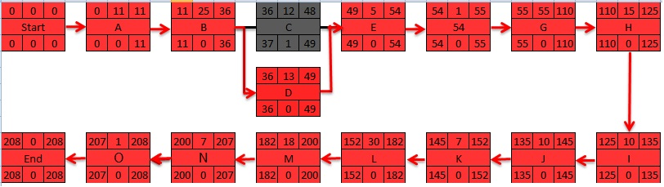

Figure 3.4 Network Diagram and Critical Path

### 3.1.8. Project Schedule

Table 3.5 is the project schedule which serves as a guide in the implementation of the system. It shows the detailed breakdown of the task list, as well as the assigned proponents for the specific task.

|  |  |  |  |
| --- | --- | --- | --- |
| Task Name | Owner | Duration |  |
| 1. Project Proposal    1. Capsule Proposal Making | All | 11 days  11 days |  |
| 1. Project Planning    1. System Analysis/Design | All | 25 days |  |
| 1. Project Preparation    1. Data Gathering | All | 12 days |  |
| 1. System Documentation   4.1 Document Making  4.2 Submission of Documents | All | 13 days  12 days  1 day |  |
| 1. Presentation Preparation    1. Mock Presentation | All | 5 days |  |
| 1. Presentation Proper | All | 1 day |  |
| 1. Software Development    1. UI Design    2. Function    3. Database Architecture | All | 55 days  15 days  20 days  20 days |  |
| 1. System Integration | All | 15 days |  |
| 1. System Testing   9.1 Unit Testing  9.2 Integration Testing  9.3 Alpha Testing  9.4 Beta Testing  9.5 Usability Testing | Roullo, Laylo  Roullo, Boyboy  Arriesgado, Abaño  Arriesgado, Abaño  Laylo. Boyboy | 10 days  2 days  2 days  2 days  2 days  2 days |  |
| 1. System Review   10.1 Evaluation of Testing Results  10.2 System Adjustments | All | 10 days  5 days  5 days |  |
| 1. Deployment and Installation | All | 7 days |  |
| 1. Evaluation   User Acceptance Testing  Evaluation of UAT | Laylo, Roullo, Boyboy  Abaño, Arriesgado | 30 days  28 days  2 days |  |
| 1. System Documentation | All | 18 days |  |
| 1. Presentation Preparation   13.1 Mock Presentation | All | 7 days |  |
| 1. Presentation Proper | All | 1 day |  |

Table 3.5 Budget Schedule

Figure 3.5 shows the Gantt chart of the project schedule. This shows a graphical timeline the proponents will be following in the implementation of the system.

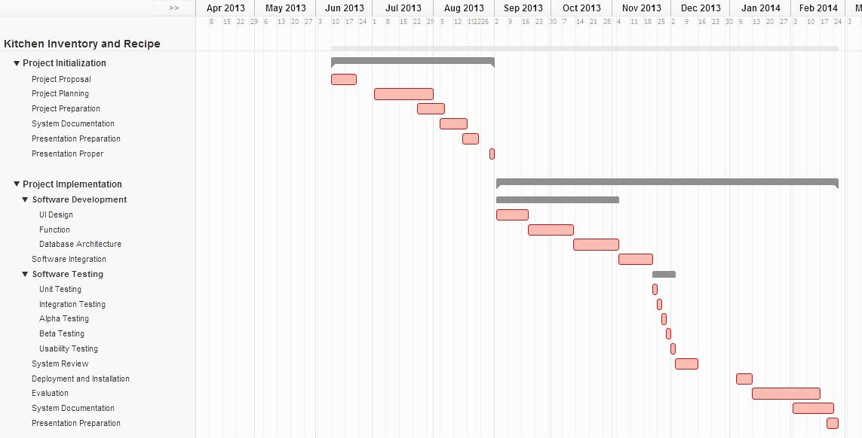

legend.jpg

Figure 3.5 Gantt Chart

### 3.1.9. Project Budget

Table 3.6 Actual Cost

|  |  |  |  |
| --- | --- | --- | --- |
| **Item Description** | **Quantity** | **Price Per Unit** | **Total Item Cost** |
|  |  | **Documentation Cost** |  |
| Printing and Documentation | 8 | Php 300.00 | Php 2,400.00 |
| Miscellaneous | 1 | Php 1,500.00 | Php 1,500.00 |
| **Total** |  |  | Php 3,900.00 |

Table 3.6 shows the list of projected cost of the study. The projected budget summarizes the expenses indicating the quantity and monetary where in Philippine Peso (Php).

## 3.2. Proposed Software Design

### 3.2.1. Hardware Requirements

The suggested hardware requirement for the project to work properly is a smartphone with a high capability that can handle Lutong Bahay

### 3.2.2. Software Requirements

During the execution of Lutong Bahay, the software would require an Android OS version 2.2 or higher

### 3.2.3. Network Requirements

The suggested network requirement for the project to get updates in Lutong Bahay is an Internet Connection.

### 3.2.4. System of Software Limitations

Lutong Bahay is limited to one application with multiple users running on a single device per household. The user can add, view, update, delete ingredients, and search recipes according to the present ingredients in the inventory. Human errors in cooking are also out of the system’s control. The application can only be installed and launched in an Android OS.

### 3.2.5. System Process Model

The proponents will use the Waterfall Development Life Cycle in developing the system. Figure 3.6 shows the software process the proponents chose to use.

Planning Stage

Analysis Stage

Design Stage

Implementation Stage

Testing Stage

Deployment Stage

Figure 3.6 Waterfall Development Life Cycle Model (why not colored???)

### 3.2.6. Software Architecture

The software architecture of a system is a set of structures needed for the system’s operation which consist the software elements and hardware elements that can be used by the software, relationship and properties. Figure 3.7 shows the Software Architecture of the proposed project.

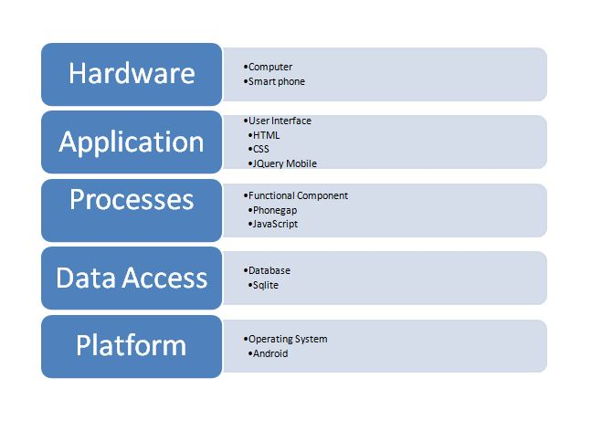

Figure 3.7 Software Architecture??? (font size too big)

### 3.2.7. Software Analysis and Design

* + Use Case

Figure 3.8 shows what the user can do in the system, the user can view the home page of the system, can add ingredient, update ingredient, look for recipes based on the ingredients in the inventory and can search the recipes base on the results of the generated recipes.

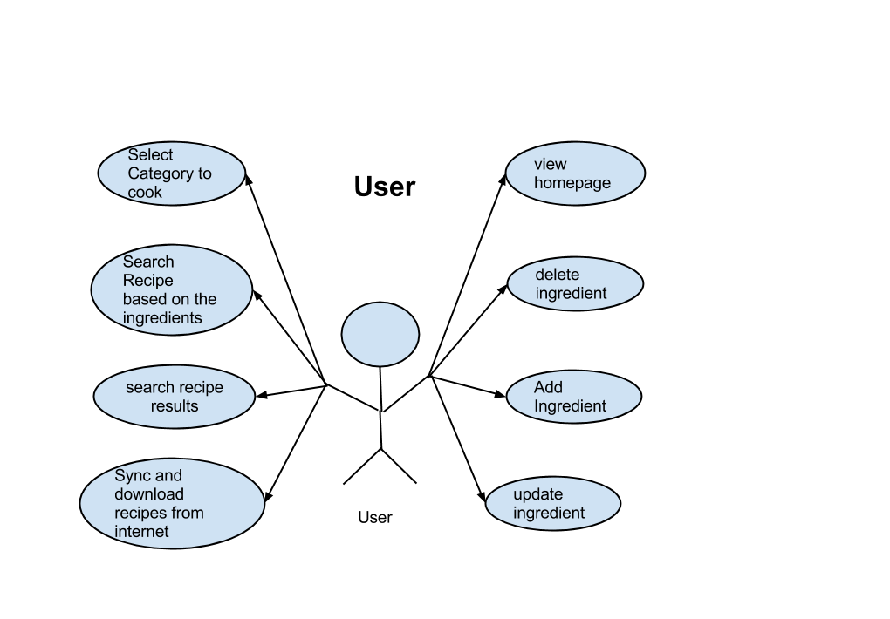

Figure 3.8 Use Case Diagram (strange diagram!!!)

* Flowchart

Figure 3.9 shows the flowchart of the main page of the program. The user has the option to choose from:

* + - Ingredients page is where the user can view the ingredients in the inventory.
    - Recipes page is where the user can view all the recipes in database and may search available recipes to cook based on the ingredients in the ingredients inventory.
    - Help page is where the user can view the about the details and the user guide of the application. The user may also update the application in this page.
    - 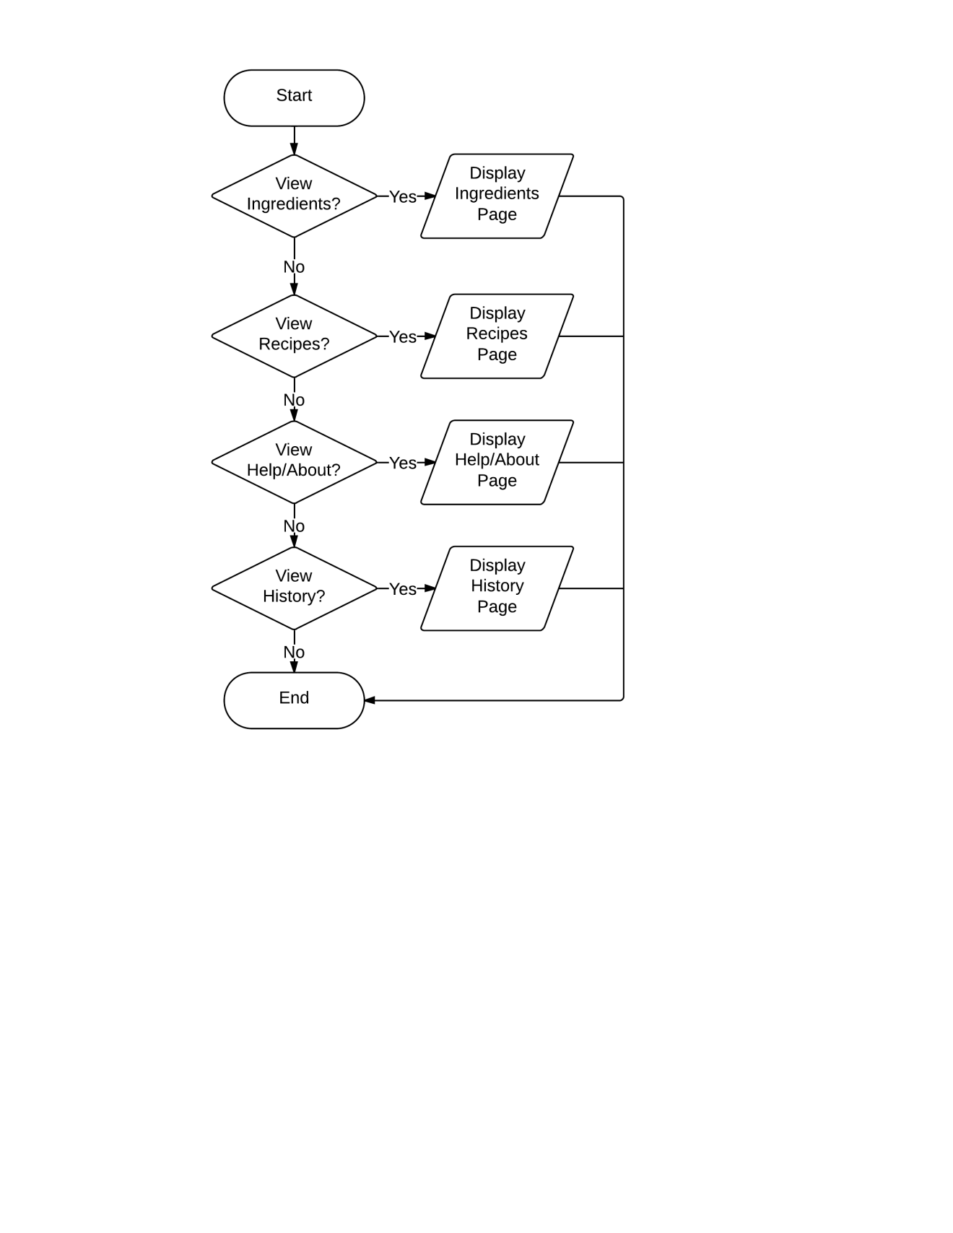History page is where the user may view the list of recipes that has been recently cooked.

Figure 3.9 Main??? Flowchart

Figure 3.10 shows how the inventory system works and managed by the user.

* + - The system will display the available ingredients entered by the user.
    - User can search an ingredient present in the inventory.
    - User can add ingredients one at a time.
    - User can select recipe ingredient to view its quantity and may delete or update the ingredient.
    - User can go back to the main page of the system.

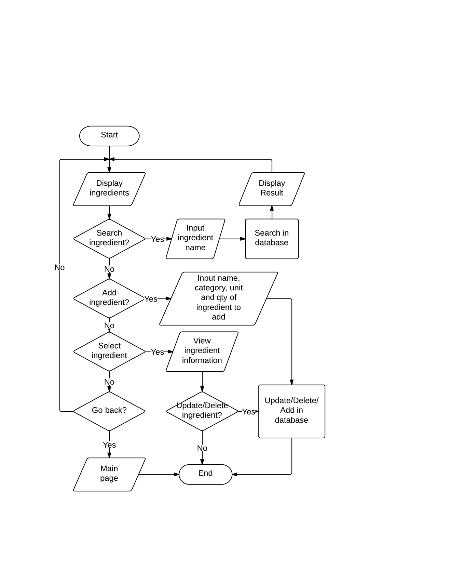

Figure 3.10 Ingredient Inventory Flowchart

Figure 3.11 shows the flowchart of the recipe page. All the recipes will be displayed first, and then if the user wants to search for search for recipes available for cooking then the user will have to input the number of servings. After which, the user can now:

* + - Display recipes by category.
    - Select a recipe to view information then may decide whether to cook or not. When the user decides to cook the recipe, ingredients needed for cooking will be automatically deducted from the inventory. Then user may go back to be able to search recipes again.

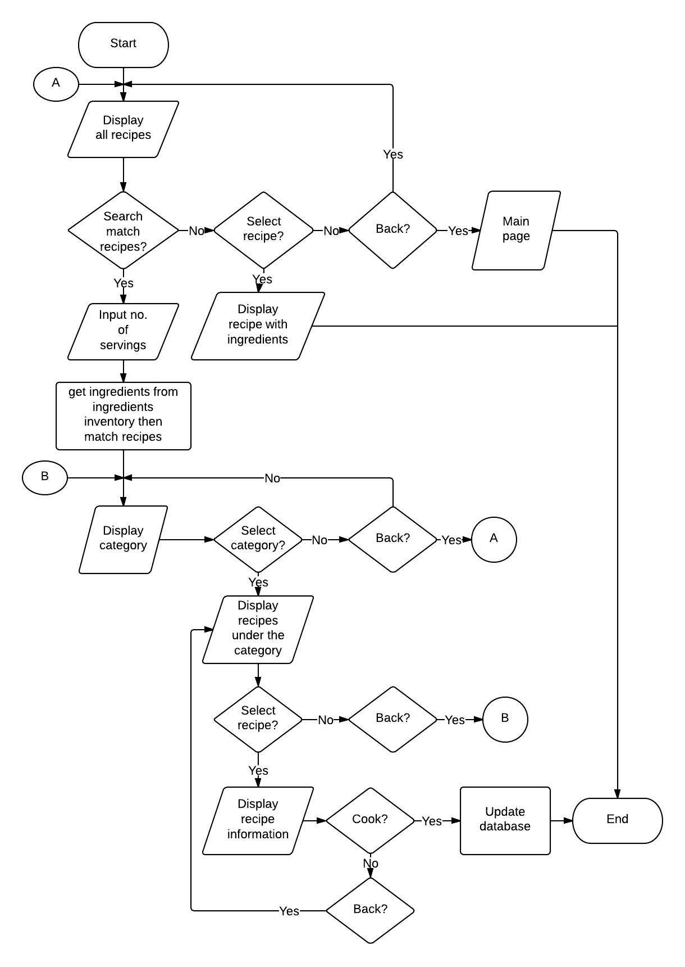

Figure 3.11 Recipe Page Flowchart

Figure 3.12 shows the flowchart of the help page. The user can view the system information and check for updates in this page.

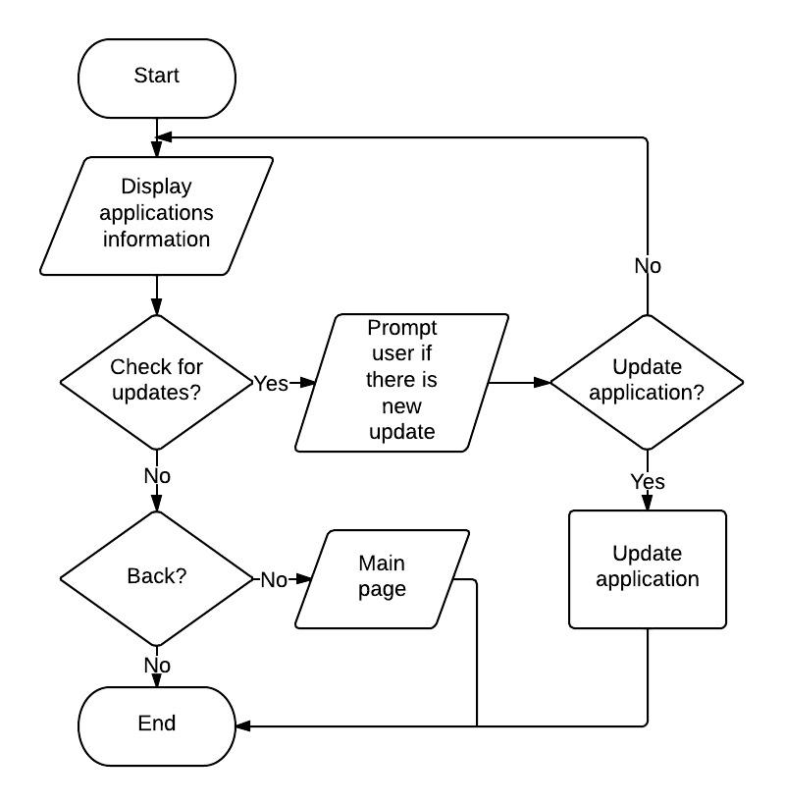

Figure 3.12 Help Page Flowchart

* Entity Relationship Diagram

Figure 3.12 shows the database structure??? of the application. This is where the ingredients from the inventory and the recipes are being stored. It also shows the relationship between different database tables.

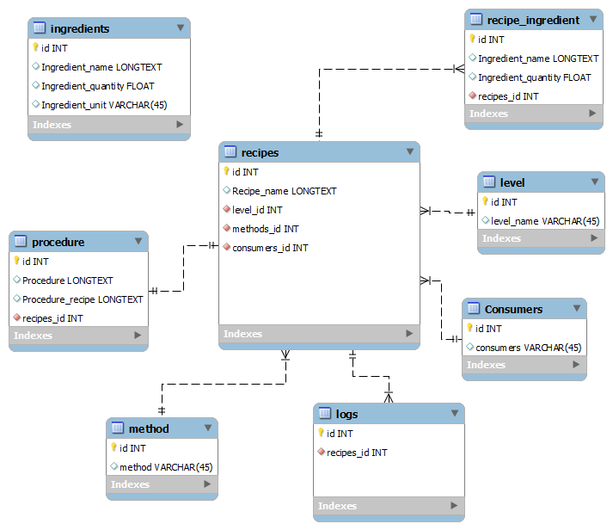

Figure 3.13 Entity Relationship Diagram (of what???)

### 

### Possible Methods

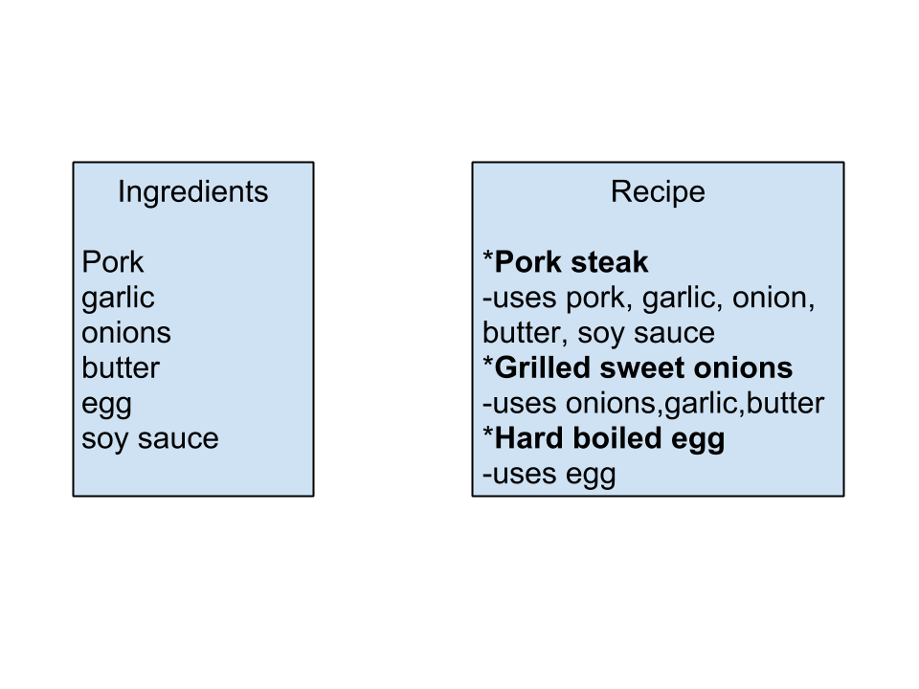There are two methods that we might use in developing the Lutong Bahay Application.

Figure 3.14 Method 1

In method 1, based from the ingredients available in the inventory the system will sort it from the recipe that uses the most of the ingredients, the system will match the ingredients from the inventory and the ingredients needed from the recipe. For example Pork steak uses five of the ingredients so it’s the most prioritized among the recipes, next is the Grilled Sweet Onions which uses three of the ingredients, next is Hard-boiled egg which only uses one of the ingredients.

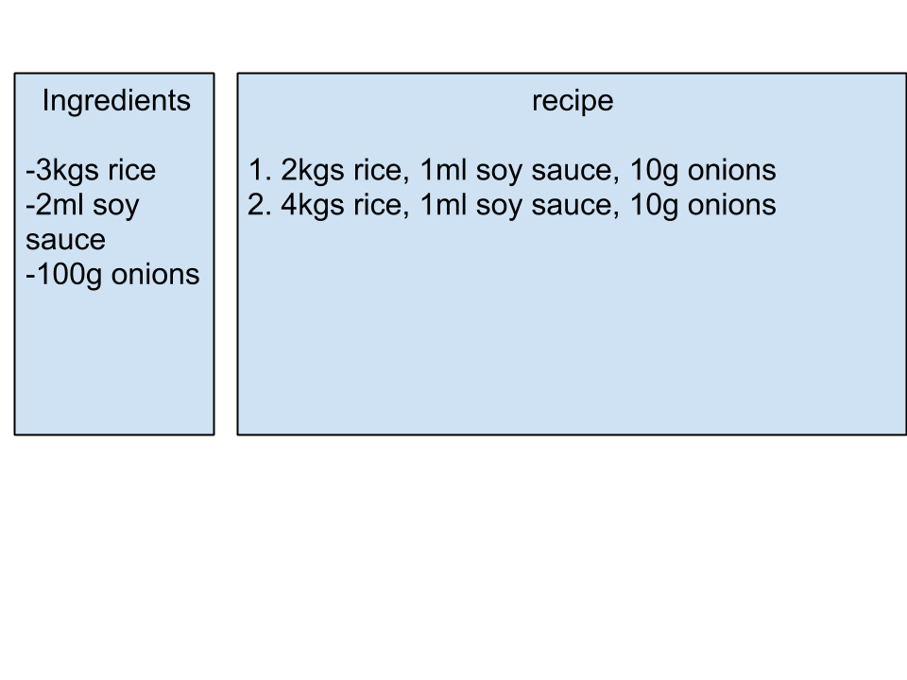

## 

Figure 3.15 Method 2

In Method 2, the recipe ingredients will be compared to each of the ingredients found in the inventory according to its quantity and unit of measurement. If the ingredients from the inventory satisfy the required quantity of recipe ingredients, all results will be sorted alphabetically and will be displayed in the recipe page of Lutong Bahay.

## 3.3. Software Testing

### 3.3.1. Unit Testing

The individual modules of the system will be tested for proper operations.

**3.3.1.1 Administrator module**

The Administrator Module will be tested according to its performance in updating the system’s information. The following test cases will verify the functions of the User Module:

Table 3. 7 Test Cases for Administrator Module

|  |  |  |  |
| --- | --- | --- | --- |
| **Test Case** | **Description** | **Test Steps** | **Expected Results** |
| Manage Use | Test for managing updates for the recipes, ingredients, and procedures. | Select  “Add New Recipe”  Button | Add Recipe Name to the new recipe to be inputted. |
|  |  | Select  “Procedures”  Button | Add Procedures to the new recipe. |
|  |  | Select  “Ingredients”  Button | Add Ingredients to the new recipe. |
|  |  | Select  “Update”  Button | Updates recipes available in the database. |
|  |  | Select  “Delete”  Button | Delete selected recipe including its procedures and ingredients. |

**3.3.1.2 User module**

The User Module will be tested according to its performance in updating the system’s information. The following test cases will verify the functions of the User Module:

Table 3.8 Test Cases for User Module

|  |  |  |  |
| --- | --- | --- | --- |
| **Test Case** | **Description** | **Test Steps** | **Expected Results** |
| Manage Use | Test for managing the ingredient inventory of the user. | Add | Adds ingredients according to what the user inputted. |
|  |  | Update | Updates the users inputted ingredients. |
|  |  | Delete | All ingredients inputted are shown and can be deleted. |

### 3.3.2. Integration Testing

Integration Testing is type of testing where all of the sub-systems are combined and tested as one.

Table 3.9 Test Cases for Integration Testing

|  |  |  |  |
| --- | --- | --- | --- |
| **Test Case** | **Description** | **Test Steps** | **Expected Results** |
| Add ingredient | Test if the user can add ingredient to the inventory. | Select “Ingredients Inventory”  Tab | Allows user to add recipe ingredients. Add button is shown. |
|  | Test if the user can input the quantity of the ingredient/s and its SI unit | Select  “Add” Tab | Allows the user to input the Quantity and SI Unit of the ingredient. The Ok button is shown. |
|  | Test if the |  |  |
|  | Test if the inputted ingredient is correct. | Select  “OK”  Button | Shows the text field of “name of the ingredient”, “category”, “unit” and the “quantity”. |
| Delete Ingredient | Test if the user can delete ingredients | Select an ingredient from the inventory then select “Delete” Tab | A window will appear to confirm deletion and will redirect back to inventory page if confirmed and ingredient will be deleted. |
| Update Ingredient | Test if the user can update ingredients. | Select an ingredient from the inventory then enter new quantity of the ingredient. | Current quantity will be replaced by the entered quantity. |
| Recipe Search | Test if user can search for recipe. | Select “Recipes”  Tab | A window will appear to enter the number of servings and redirects to the recipe page. Search button and new search button is shown. |
|  | Test if the user can input the number of servings. | Input the number of servings . | Inputs the number of servings given by the user and redirects to “Select Category” page. |
|  | Test if the user can select a category. | Select a Category. | Shows the categories and shows the tabs of each categories which are the “Difficulty”, “Consumers”, “Methods”, and “All”. |
|  | Test if the user can select the degree of difficulty in cooking. | Select Diffuculty | Shows the degree of difficulties, “Basic”, “Advance” and “All” tabs are shown. |
|  | Test if the user can select methods in cooking. | Select Method | Shows the methods in cooking such as “Fried”, “Grilled” and “Soup”. Tabs of the methods are shown. |
|  | Test if it shows all the recipes. | Select  “All”  Tab | Shows all the matched recipes base from the inputted ingredients and categories. |
|  | Test if user can search for more or a new recipe. | Select  “New Search”  Button | Allows the user to  search for another  recipe. A pop-up  message will  appear and ask for  number of  serving. |
| Cook a Recipe | Test if the system can match or suggest recipe base from the ingredients you inputted. | Select a Recipe from the searched results | Shows the ingredients you inputted and the procedure of the recipe. A cook recipe button is shown. |
|  | Test if the ingredients in the inventory are deducted. | Select “Cook Recipe”  Button | Asks confirmation to the user to cook and deducts the ingredients inputted from the database. |
| View information and updates. |  | Select “About”  Tab | Shows the name of the developers and the name of the smartphone application. “Sync” button is shown. |
|  |  | Select  “Sync”  Button | Sync for new updates or new available recipes provided by the administrators. |
| View cooked recipes |  | Select  “Logs”  Tab | User can view recently cooked recipes. |

**3.3.3. Alpha Testing**

This testing is to find errors and possible bugs that were not found during the integration testing. The following are the guidelines for the Alpha Testing:

* + User can input ingredients.
  + User can input recipes to search.
  + User can delete ingredients.
  + User can update ingredients.
  + User can enter the number of servings to search for recipes.
  + User can select the difficulty in cooking.
  + User can select the methods in cooking.
  + User can select its consumers.
  + User can input the quantity with regards to the unit in SI.
  + User can view the guidelines and instructions.

### 3.3.4. Beta Testing

The system will be checked if the it meets the requirements of the clients. Output of this testing will help the proponents improve the system and also to find out bugs and errors that has not been found during alpha testing. The guidelines in Alpha testing will also be used in Beta testing.

### 3.3.5. User Acceptance Testing

The User Acceptance Testing will begin after the system has been deployed. It is done by the clients in a particular location in which the clients determine whether the system meets the guidelines and feedbacks will be gathered. The following guidelines will be used to gather feedback from the participants during the user acceptance testing:

* Does the system have a user-friendly user interface? Is the system’s layout comfortable?
* Does the system perform its specified functions?
* Are the data consistent throughout the system? Are these data correct and reliable?
* Does the system come with proper documents?

### 3.3.6. Usability Testing

The feedback gathered from the clients will be used in evaluating the system’s user-friendliness. The following guidelines will be used to verify the system’s usability:

* Is the system’s user interface pleasing to the eyes?
  + Are the fonts used easy to read?
  + Are the colors used pleasing to the eyes?
  + Are the placements of the buttons positioned properly?
* Does the system provide easy-to-use functions?
  + Do the button functions come with easy to understand instructions?

## 3.4. Deployment

At the end of the software development and testing, the system will be deployed on the mobile to undergo user acceptance testing

Lutong Bahay will be deployed to the user as a free software. The installation of the system may take several minutes as a whole. The target users are those who have smartphones with version 2.2 and up Android OS.

## 3.5. Data Gathering and Interpretations (sample size and population???)

System evaluation is very essential to make room for improvement. This can be done through gathering and interpretation of user’s feedback. The interpretations would be the basis of knowing the system’s performance and would be the means to plan for the improvement of the system.

### 3.5.1. Gathering of Data

This study used the qualitative style research to gather information or feedback from the users. The analysis focused on the qualities of the smartphone. For quantification, a frequent count, as well as a tally will be used based on the user’s answers to the survey.

The gathering utilized the use of a questionnaire to acquire relevant data and feedback from the users. As a means to ensure the consistency of the answers, counterchecking questions answered by the users were used.

In gathering the recipes used in the application, the proponents will use the internet as the source and will gather as many sources as possible and integrate the recipes from them to arrive to some common recipes that are cooked.

### 3.5.2. Treatment of Data

Since the proponents seek to measure the usability of the system, the proponents will conduct a heuristic kind of evaluation.

The system will be evaluated according to three qualities: User-friendliness, Portability, and Completeness. Each of these qualities was rated by the users with a spectrum ranging from one to four (1-4), one (the user strongly disagrees), two (disagree), three (agree), four (strongly agree).

The questionnaires will be answered by the users and the answers will be sorted by quality. Their comments, suggestions, reactions and feedbacks regarding quality of the mobile application will be accounted and tabulated where the frequency are shown. The tabulated results will be calculated for its average using weighted averaging method.

In order for the researcher to know the average rating of each quality, a range computation was used using the equation:

Equation 3.1 Range

**Where :**

H – Highest value of rating.

L – Lowest value of rating.

N – Number of rating options.

Substituting the numbers to the equations would result to an answer of 0.75, which means the ranges will have a 0.75 interval in between. Hence, we could say that (1.0 – 1.75) falls to the Strongly Disagree, (1.76 – 2.50) falls to the Disagree, (2.51 – 3.25) falls to the Agree, and (3.26 – 4.0) falls to the Strongly Agree.

Bar graphs will be utilized to properly exhibit the results which will then be used for the said improvements.

# HYPOTHESIS

With all the necessary preparation and information for the development of the smartphone application, the proponents will now have the ability to deploy the said application on schedule.

Lutong Bahay will help the user in monitoring the availability of ingredients in the kitchen through the ingredient inventory system. This will provide convenience to the user in selecting recipes to cook based on the available ingredients.

# BIBLIOGRAPHY (check proper format, be consistent with the rest of the authors!!!)

Berkovsky, S. and Freyne, J. 2010 “Intellegent Food Planning: Personalized Recipe Recommendation”. [IUI'10](http://iuiconf.org/) Proceedings of the 15th international conference on Intelligent user interfaces, 321-324. Accessed on August 16, 2013. doi:[10.1145/1719970.1720021](http://dx.doi.org/10.1145/1719970.1720021)

# Charland, Andre and Leroux, Brian. 2011. “Mobile Application Development: Web vs. Native.” Communications of ACM (54), May, 49-53. Accessed July 2013.

doi:[10.1145/1941487.1941504](http://dx.doi.org/10.1145/1941487.1941504)

|  |
| --- |
|  |

# Farooqui, Shahab H. (2013). Home Library, Accessed on July 2013. https://

# itunes.apple.com/us/app/home-library/id399196568?mt=8&affId=1805214

# General Mills Incorporated. (2013). “The Betty Crocker Mobile Cookbook”. Apple.Accessed on August 20, 2013. <http://itunes.apple.com/ph/app/betty-crocker-mobilecookbook/id304132604?mt=8>

Ibrahim, Hamidah, Karasneh, Yaser , Othman, Mohamed and Yaakob, Razali 2009. “Schema Matching and Data Integration”.Proceedings of World Academy of Science: Engineering & Technology 50 : 1205-1208. Accessed on August 16, 2013. <http://ehis.ebscohost.com/eds/detail?sid=6e0a6426-c5ad-4fb7-a059-7589fdc7b84f%40sessionmgr10&vid=1&hid=7&bdata=JnNpdGU9ZWRzLWxpdmU%3d#db=a9h&AN=39876822>

# Levitt, Daniel. 2009. “Case Study: Recipe Search MicroApp”. The Guardian. Accessed on July 25, 2013. <http://www.theguardian.com/open-platform/blog/recipe-searchmicroapp>

# Mike Lajeunesse. (2013). “Inventory Matching Software”. Medical Materials. Accessed on July 13, 2013. http://[www.medicalmaterials.com/customer_tools.html](http://www.medicalmaterials.com/customer_tools.html)

Muli, Mihwa. "Android as a Platform for Database Application Development - Case: Winha Mobile". Turku University of Applied Sciences, 2013.

Popovici, Radu, et. al., "Cookbook: An Android Mobile Platform Application" Annals of DAAAM for 2009 & Proceedings of the 20th International DAAAM Symposium 20(2009): 0277-0278.

Stark, Jonathan. Building Android Apps with HTML, CSS, and JavaScript, 2010.

## APPENDIX A

This is the proposed graphical user interface of Lutong Bahay.

* 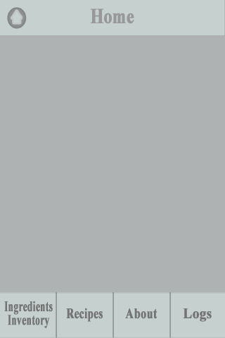Main page
* Ingredients inventory page
* From the main page, tap on Ingredients Inventory then the ingredients inventory page will appear showing all the ingredients inputted by the user.

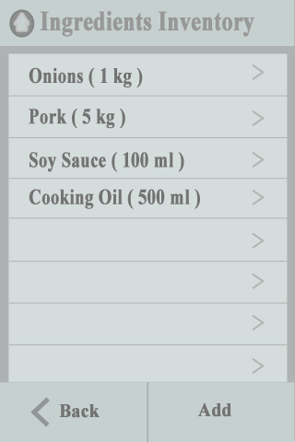

* Adding an Ingredient
* From the ingredients inventory page, tap on add then input the ingredient name, quantity and unit then tap “ok”
* 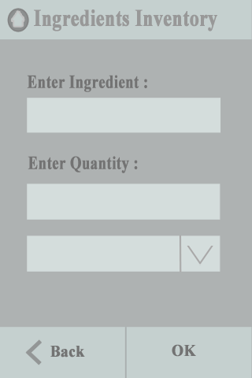
* Updating/Deleting an ingredient
* Select an ingredient from the ingredients inventory list. The user may update or delete the selected ingredient. Upon deleting an ingredient, a message will pop up for confirmation. To update an ingredient, the user will have to input the quantity then tap on “Update”.

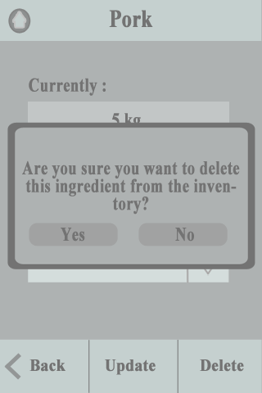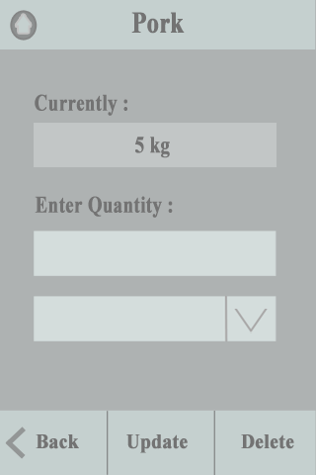

* Log page

-From the main page, tap on the log page. This page shows the recently cooked recipes.

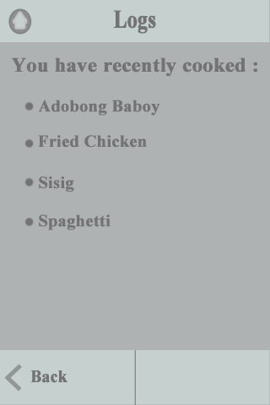

## APPENDIX B

**STUDENT’S ACCEPTANCE OF PROPOSAL PROJECT**

**July 2, 2013**

**Dr. Marlowe Burce**

University of San Carlos

Nasipit, Talamban, Cebu City

Dear **Dr. Burce:**

I, **Chariz Stephanny O. Abaño**, with ID number **09304310**, accept the position as researcher for the project entitled: **Lutong Bahay: An Ingredient Inventory and Recipe Smartphone Application.**

I acknowledge the role and responsibility that will be given to me. And I also agree to abide to the rules set by the team.

To make this agreement legal and binding, I hereby affix my signature below.

**Chariz Stephanny O. Abaño**

Noted by:

**Engr. Linda E. Saavedra**

Coordinator, ComE 513 – Design Project Proposal

**Engr. Van B. Patiluna**

Chairman, Department of Computer Engineering

**STUDENT’S ACCEPTANCE OF PROPOSAL PROJECT**

**July 2, 2013**

**Dr. Marlowe Burce**

University of San Carlos

Nasipit, Talamban, Cebu City

Dear **Dr. Burce:**

I, **Apple Regine Y. Arriesgado**, with ID number **09304149,** accept the position as researcher for the project entitled: **Lutong Bahay: An Ingredient Inventory and Recipe Smartphone Application.**

I acknowledge the role and responsibility that will be given to me. And I also agree to abide to the rules set by the team.

To make this agreement legal and binding, I hereby affix my signature below.

**Apple Regine Y. Arriesagado**

Noted by:

**Engr. Linda E. Saavedra**

Coordinator, ComE 513 – Design Project Proposal

**Engr. Van B. Patiluna**

Chairman, Department of Computer Engineering

**STUDENT’S ACCEPTANCE OF PROPOSAL PROJECT**

**July 2, 2013**

**Dr. Marlowe Burce**

University of San Carlos

Nasipit, Talamban, Cebu City

Dear **Dr. Burce:**

I, **Christian Emmanuel B. Boyboy,** with ID number **<student’s id number>**, accept the position as researcher for the project entitled: **Lutong Bahay: An Ingredient Inventory and Recipe Smartphone Application.**

I acknowledge the role and responsibility that will be given to me. And I also agree to abide to the rules set by the team.

To make this agreement legal and binding, I hereby affix my signature below.

**Christian Emmanuel B. Boyboy**

Noted by:

**Engr. Linda E. Saavedra**

Coordinator, ComE 513 – Design Project Proposal

**Engr. Van B. Patiluna**

Chairman, Department of Computer Engineering

**STUDENT’S ACCEPTANCE OF PROPOSAL PROJECT**

**July 2, 2013**

**Dr. Marlowe Burce**

University of San Carlos

Nasipit, Talamban, Cebu City

Dear **Dr. Burce:**

I, **Luke Nigel J. Laylo,** with ID number **09304312**, accept the position as researcher for the project entitled: **Lutong Bahay: An Ingredient Inventory and Recipe Smartphone Application.**

I acknowledge the role and responsibility that will be given to me. And I also agree to abide to the rules set by the team.

To make this agreement legal and binding, I hereby affix my signature below.

**Luke Nigel J. Laylo**

Noted by:

**Engr. Linda E. Saavedra**

Coordinator, ComE 513 – Design Project Proposal

**Engr. Van B. Patiluna**

Chairman, Department of Computer Engineering

**STUDENT’S ACCEPTANCE OF PROPOSAL PROJECT**

**July 2, 2013**

**Dr. Marlowe Burce**

University of San Carlos

Nasipit, Talamban, Cebu City

Dear **Dr. Burce:**

I, **Christian B. Roullo,** with ID number **<student’s id number>**, accept the position as researcher for the project entitled: **Lutong Bahay: An Ingredient Inventory and Recipe Smartphone Application.**

I acknowledge the role and responsibility that will be given to me. And I also agree to abide to the rules set by the team.

To make this agreement legal and binding, I hereby affix my signature below.

**Christian B. Roullo**

Noted by:

**Engr. Linda E. Saavedra**

Coordinator, ComE 513 – Design Project Proposal

**Engr. Van B. Patiluna**

Chairman, Department of Computer Engineering

**ADVISER’S LETTER OF ACKNOWLEDGMENT**

**July 6, 2013**

**Engr. Linda Saavedra**

Coordinator, ComE 513

University of San Carlos

Nasipit, Talamban, Cebu City

Dear **Engr. Saavedra:**

I, **Dr. Marlowe Burce,** accepts the position as **ADVISER** for the group with the project entitled: **Lutong Bahay: An Ingredient Inventory and Recipe Smartphone Application.**

I acknowledge the role and responsibility of an adviser as stated on Section 2.8.2 of the ComE 513 Polices and Guidelines.

To make this agreement legal and binding, I, together with the proponents, hereby affix our signatures below.

**Dr. Marlowe Edgar C. Burce, PhD**

**Chariz Stephanny O. Abaño** **Apple Regine Y. Arriesgado**

**Christian Emmanuel B. Boyboy Luke Nigel J. Laylo** **Christian B. Roullo**

Accepted by: Noted by:

**Engr. Van B. Patiluna** **Dr. Evelyn Taboada**

Chairman, Department of Computer Engineering Dean, College of Engineering

## APPENDIX C

**TEAM PROFILE**

**Personal Information**

**Name :** Chariz Stephanny O. Abaño

**Nickname :** Aying

**City Address :** M dela Concepcion St. Pasil, Suba, Cebu City

**Telephone Number :** 238-2784

**Cellphone Number :** +639333892695

**Email Address :** chariz_stephanny@yahoo.com

**Birthdate :** February 3, 1992

**Gender :** Female

**Religion :** Roman Catholic

**Nationality :** Filipino

**Educational Background (change order!!!, make sure same formatting with other proponents)**

**Elementary :** Saint Mary’s Academy (City/Province)

(1999-2000)

Young Ladies Association of Charity

(2000-2005)

**Secondary :** Cebu Institute of Technology-University

(2005-2009)

**Tertiary :** University of San Carlos Technological Center,

Bachelor of Science in Computer Engineering

Major in Software Engineering, 5th Year

(2009-present)

**Personal Information**

**Name :** Apple Regine Y. Arriesgado

**Nickname :** Apple

**City Address :** 695-a Parts Boarding House, Banilad, Cebu City

**Provincial Address :** Maya Daanbantayan Cebu

**Telephone Number :** 437-3024

**Cellphone Number :** +639327857968

**Email Address :** appleregine@gmail.com

**Birthdate :** March 21, 1993

**Gender :** Female

**Religion :** Roman Catholic

**Nationality :** Filipino

**Educational Background**

**Elementary :** AFM Daanbantayan Learning Center

(1999-2005)

**Secondary :** Cebu Technological University Daanbantayn Campus

(2005-2009)

**Tertiary :** University of San Carlos Technological Center,

Bachelor of Science in Computer Engineering

Major in Software Engineering, 5th Year

(2009-present)

**Personal Information**

**Name :** Christian Emmanuel B. Boyboy

**Nickname :** Boyax

**City Address :** Tayud Consolacion Cebu

**Telephone Number :** 424-6476

**Cellphone Number :** +639228769440

**Email Address :** b.boyax@gmail.com

**Birthdate :** August 19, 1992

**Gender :** Male

**Religion :** Roman Catholic

**Nationality :** Filipino

**Educational Background**

**Elementary :** Tipolo Elementary School

(1999-2005)

**Secondary :** University of the Visayas

(2005-2009)

**Tertiary :** University of San Carlos Technological Center,

Bachelor of Science in Computer Engineering

Major in Computer Networks, 5th Year

(2009-present)

**Personal Information**

**Name :** Luke Nigel J. Laylo

**Nickname :** Luke

**City Address :** 53 Ylaya Talamban Cebu City

**Telephone Number :** 422-2209

**Cellphone Number :** +639336651237

**Email Address :** lukelaylo@gmail.com

**Birthdate :** December 16, 1992

**Gender :** Male

**Religion :** Roman Catholic

**Nationality :** Filipino

**Educational Background**

**Elementary :** University of San Carlos- Boys High School

(1999-2005)

**Secondary :** University of San Carlos- North Campus

(2005-2009)

**Tertiary :** University of San Carlos Technological Center,

Bachelor of Science in Computer Engineering

Major in Computer Networks, 5th Year

(2009-present)

**Personal Information**

**Name :** Christian B. Roullo

**Nickname :** Kit

**City Address :** 96-B Gorordo Avenue Cebu City

**Telephone Number :** 235-3728

**Cellphone Number :** +639323018838

**Email Address :** kitroullo@gmail.com

**Birthdate :** April 30, 1992

**Gender :** Male

**Religion :** Roman Catholic

**Nationality :** Filipino

**Educational Background**

**Elementary :** University of Southern Philippines Foundation

(1999-2005)

**Secondary :** Lyceum de Cebu

(2005-2009)

**Tertiary :** University of San Carlos Technological Center,

Bachelor of Science in Computer Engineering

Major in Computer Networks, 5th Year

(2009-present)

University of San Carlos



DEPARTMENT OF COMPUTER ENGINEERING

Talamban Campus, Cebu City

# Project Proposal Documentation Grade Sheet

**Project Title : Lutong Bahay: An Ingredient Inventory and Recipe Smartphone Application**

**Adviser : Dr. Marlowe Edgar C. Burce, PhD**

**Co-Adviser : Engr. Arnold V. Roso**

**Proponents : Chariz Stephanny O. Abaño; Apple Regine Y. Arriesgado; Christian Emmanuel B. Boyboy; Luke Nigel J. Laylo; Christian B. Roullo**

**Documentation Rating ( 60% ): Committee’s Rating**

|  |  |  |  |
| --- | --- | --- | --- |
| **Chapter 1 (25%)** |  |  |  |
| Introduction | **16%** |  |  |
| The Problem | **12%** |  |  |
| Goals and Objectives | **32%** |  |  |
| Significance of the Study | **8%** |  |  |
| Scope and Limitation | **16%** |  |  |
| Theoretical Background | **12%** |  |  |
| Definition of Terms | **4%** |  |  |
| **Chapter 2 (15%)** |  |  |  |
| Review of Related Literature | **100%** |  |  |
| **Chapter 3 (50%)** |  |  |  |
| Project Management | **30%** |  |  |
| Proposed System / Software Design | **30%** |  |  |
| System / Software Testing | **20%** |  |  |
| Deployment and Maintenance | **10%** |  |  |
| Data Gathering and Interpretations | **10%** |  |  |
| **Others (10%)** |  |  |  |
| Hypothesis | **30%** |  |  |
| Bibliography | **20%** |  |  |
| Appendices | **50%** |  |  |

|  |  |  |
| --- | --- | --- |
| **RATING GUIDE** | | |
| A + = 100 | B - = 75 | D = 50 |
| A = 95 | C + = 70 | D - = 40 |
| A - = 90 | C = 65 | E+ = 30 |
| B + = 85 | C - = 60 | E = 20 |
| B = 80 | D+ = 55 | E - = 10 |
| F = 0 (NOT IMPLEMENTED) | | |

**_________________________________________**

**Name and Signature of Evaluator**

**_________________________________________**

**Date Evaluated**

University of San Carlos



DEPARTMENT OF COMPUTER ENGINEERING

Talamban Campus, Cebu City

# Project Proposal Presentation Grade Sheet

|  |  |  |  |  |  |  |
| --- | --- | --- | --- | --- | --- | --- |
| **Presentation Rating ( 40% )** | | **Name of Proponents** | | | | |
|  |  |  |  |  |
| **Time Management**  Presentation does not exceed allotted time | **5%** |  |  |  |  |  |
| **Personal Appearance**  Proponent appears presentable and neat wearing the prescribed dress  code | **5%** |  |  |  |  |  |
| **Visualization**  Readability, proper use of fonts, quality of slides | **10%** |  |  |  |  |  |
| **Completeness of the Presentation** | **20%** |  |  |  |  |  |
| **Presentation**  Organization of ideas, ability to deliver | **20%** |  |  |  |  |  |
| **Ability to answer questions**  Answers the questions clearly and confidently | **40%** |  |  |  |  |  |

|  |  |  |
| --- | --- | --- |
| **RATING GUIDE** | | |
| A + = 100 | B - = 75 | D = 50 |
| A = 95 | C + = 70 | D - = 40 |
| A - = 90 | C = 65 | E+ = 30 |
| B + = 85 | C - = 60 | E = 20 |
| B = 80 | D+ = 55 | E - = 10 |
| F = 0 (NOT IMPLEMENTED) | | |

**_________________________________________**

**Name and Signature of Evaluator**

**_________________________________________**

**Date Evaluated**

University of San Carlos



DEPARTMENT OF COMPUTER ENGINEERING

Talamban Campus, Cebu City

# Summary of Revisions

**Proposal Hearing**

|  |
| --- |
| **Title of Project : Lutong Bahay: An Ingredient Inventory and Recipe Smartphone Application** |
| **Adviser** **: Dr. Marlowe Edgar C. Burce, PhD** |
| **Co-Adviser** **: Engr. Arnold V. Roso** |
| **Proponents : Chariz Stephanny O. Abaño**  **Apple Regine Y. Arriesgado**  **Christian Emmanuel B. Boyboy**  **Luke Nigel J. Laylo**  **Christian B. Roullo** |
| **Name of Panel :** |
| **Date of Presentation** **:** |
| **Signature :** |

Dear Committee Member,

Please outline in this summary sheet all the revisions necessary (if any) as determined. Kindly submit this form, together with the grade sheets, to the coordinator immediately after the oral defense. The adviser and other committee members will be furnished a copy of this as soon as possible; a copy will also be kept in the department file.

|  |
| --- |
|  |
|  |
|  |
|  |
|  |
|  |
|  |
|  |
|  |
|  |
|  |
|  |
|  |
|  |
|  |
|  |
|  |
|  |
|  |